**HW 22 FIX THE PITFALLS**

in the code when creating a new teacher, it was fine, the only bad thing is that the button where it was placed made many functions, and it should do few or even 1, and that was what was improved.

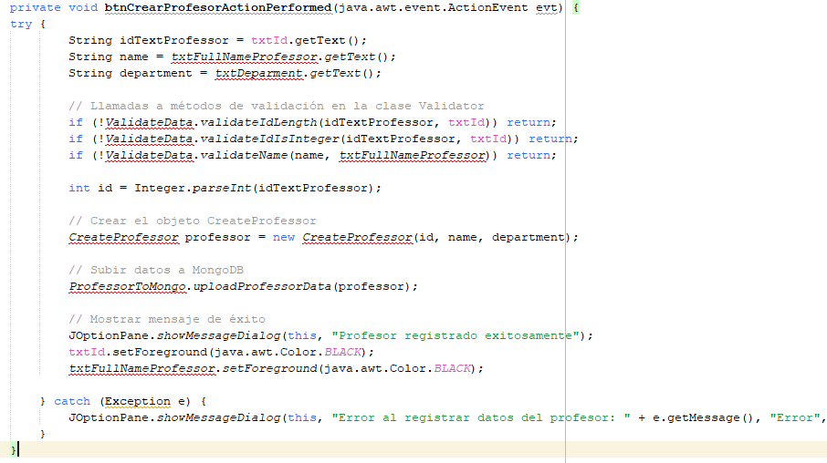

now the code of the button to create the teacher has few functions, and of which there are functions outside of this to not alter the code.

